Step by step to repair mainboard:
Step by step to repair mainboard:
Step 1: Power button:
If there is power step 2, otherwise check power supply circuit , including: stand by 3v3 , chip SiO, Southbridge.
Standby 3V3:
- 5v standby voltage from ATX will lower down to 3v3 for the southbridge, often using an ic 1117 or 1084, 1085, 1086 (pin 3; input ATX STB 5V, pin 2; output 3v3 STB. The main life bulbs are not used IC which uses a circuit with few or MOSFET transistor to stabilize pressure.).
- Check 3V3 at A14 pin PCI slot (see picture).
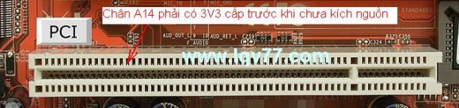
See PCI pinout in pinouts.ru
http://pinouts.ru/Slots/PCI_pinout.shtml
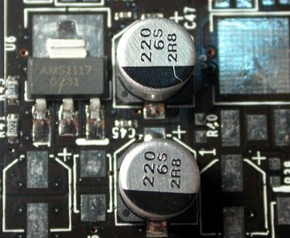
The cause of death 3v3 stand by this:
- Death ic 1117/1084/1085/1086
- Died LAN, Sound onboard
- Death southbridge
Chip SIO & Southbridge:
- 3v3 STB Otherwise, continue with chip SiO.
- Circuit power is booted, there are three following types (see picture):
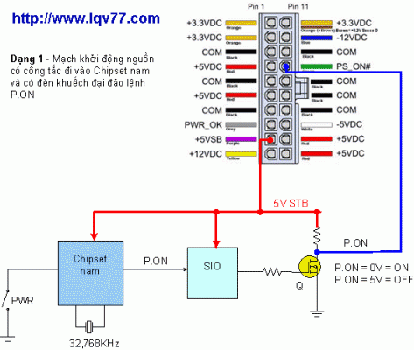
Type 1: PWR button from the southbridge, ATX ps_on to MOSFET (polarity reversal) and the chip SiO.
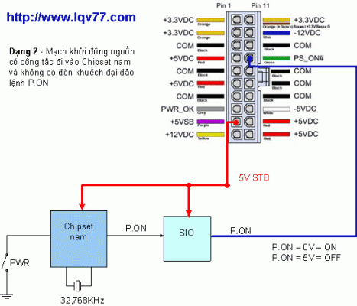
Type 2: no MOSFET, ATX po_on go directly to SiO.
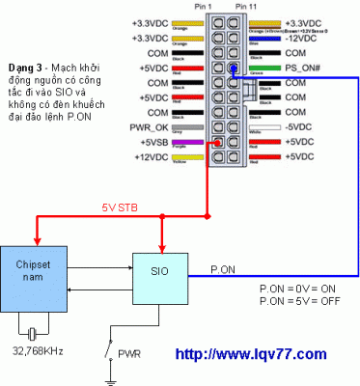
Type 3: PWR button on SiO.
PWR button (ps-on/pw on in F_Panel):
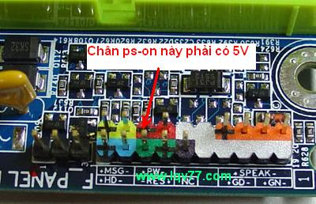
If the circuit well, southbridge activities, PWR button to have 2v5 ~ 5V. If lost, check SiO, Southbridge. If a volte PWR button, click the source is not, check Mosfet (polarity reversal), South Bridge chip, chip SiO.
Note: Quartz 32.768Khz southbridge bug will not work.

Voltage regulator module for CPU (Vcore)
1. Circuit components:
* First 4 pin 12V Power Supply
* IC fluctuations
* The driver IC
* The power Mosfet
* The coil (around the CPU, to identify specific)
* Input filtering capacitor 16V/1200FF 3300MF ...
* VCore 6.3V/820MF filtering capacitor 3300MF ...
2. How to identify and circuit layout on the motherboard:
- The coil, filter capacitors and MOSFETs around the CPU.
- Denmark is conspicuous by arranging events, including links 2, 3 or 4 2 or 3 coils with each coil MOSFET and a wealth of convergence of around CPU socket connector.
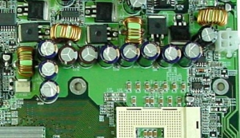
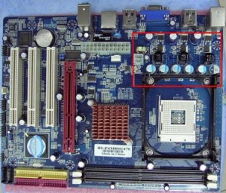
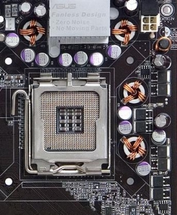
- In this circuit, when we have not plugged the CPU (Pentium 4 or higher) on the socket will not have the source (if there is a faulty circuit). When you plug the CPU into the power circuit that automatically correct for the CPU needs. To measure the power supply for the CPU test we measure at the foot of the wire. Note in the above line is a filter lane on the roll will be scattered with the coil voltage 12V output filter is a new source of supply for the CPU.
- If the plug does not support the main CPU will have no power at the output vCore. To fix, use at home to check CPU VRM circuit is the best.
3. General diagram:
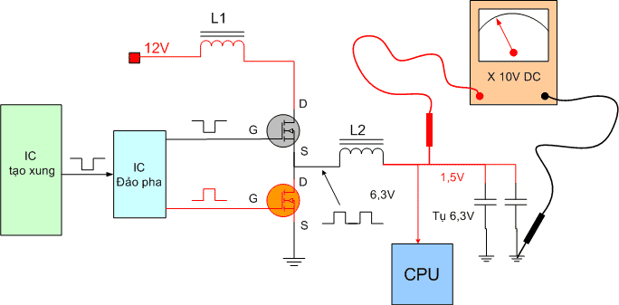
4. Map of the actual circuit principle:
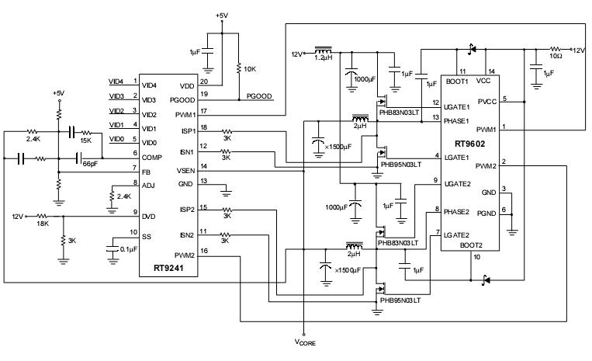
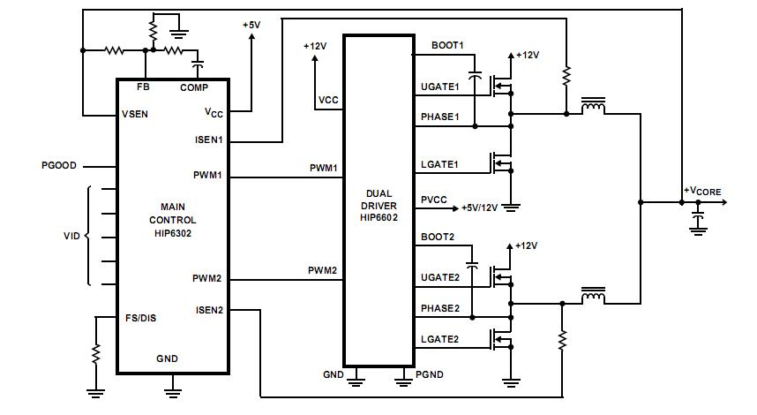
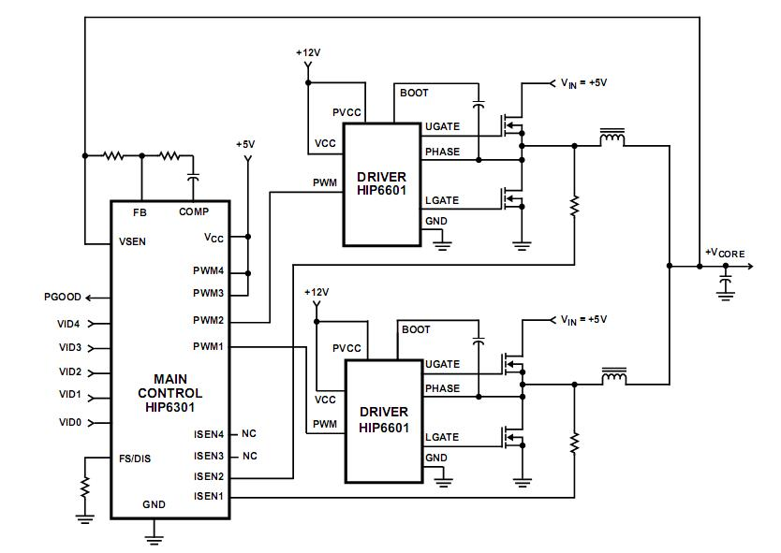
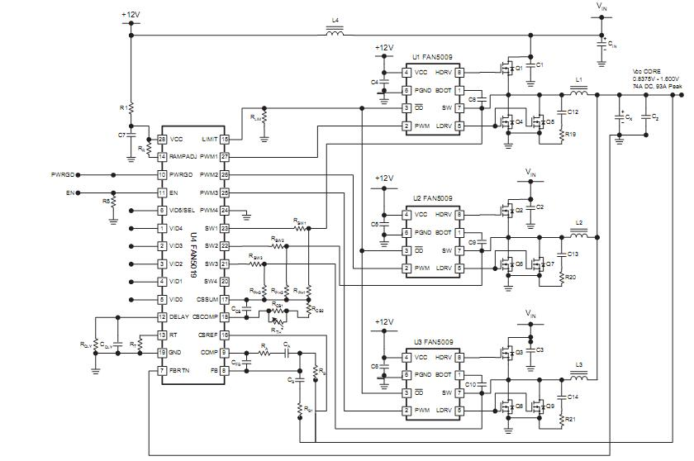
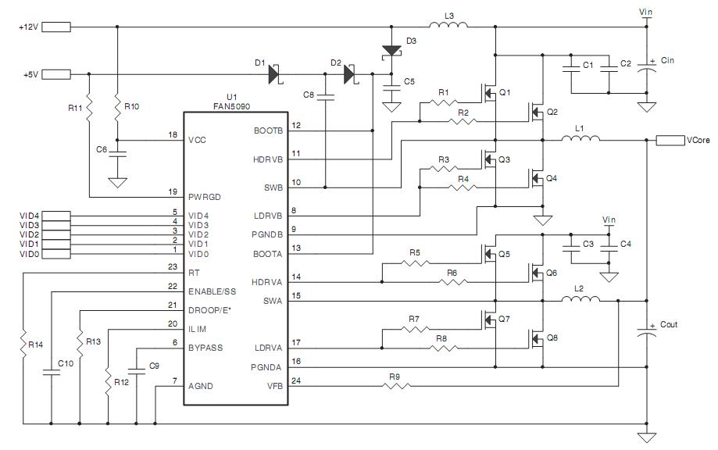
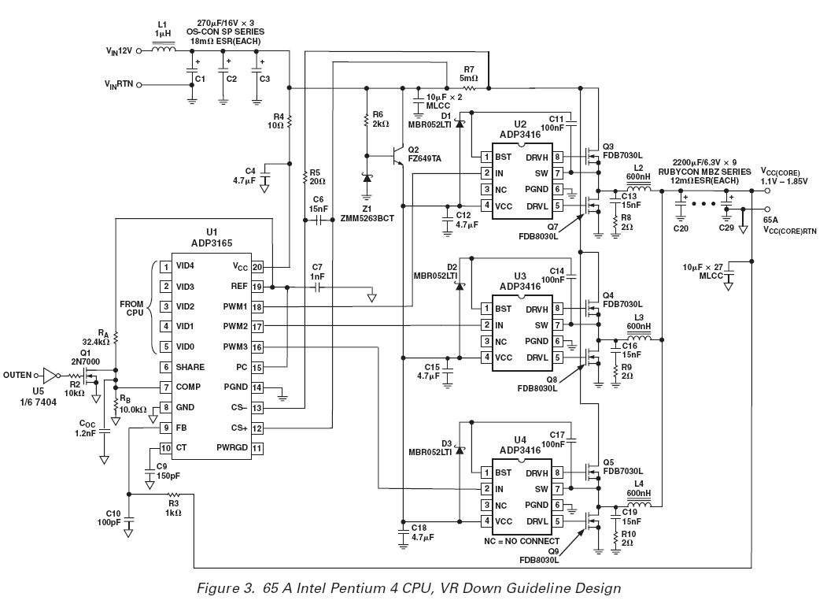
- The circuit, using an IC to pulse and a 0, 1, 2 or 3 for the MOSFET driver IC to operate. VCore is the source of supply for the CPU.
5. Analysis of circuit operation:
- For most motherboards, you just power the motherboard (not plug anything even more CPU and RAM) that can then click source. With a few individual cases (especially the motherboard of Intel), must try the new CPU is the source size.
- When you click the source was running, the first check for sources and has enough RAM or not (there will be a specific article regarding this issue.) Then check the CPU power supply has been or not.
- Note: When you plug the CPU is not the source of supply for the CPU will always be zero. If a pressure vessel that is corrupted. When plugged into the CPU if that CPU requirements imposed 1.25V (This is optional each CPU, refer to the Intel CPU or attached documents to know the exact level of resources required by each type of CPU), the circuit must meet right. That must have at output 1.25V vCore.
6. Operating the circuit:
- When the Power Good signal (pin 19 IC RT9241 - first picture), pin 16, 17 will have the pulse signals PWM1, PWM2 enable the driver IC (pin IC RT9602 1.2) pulse at Pin 4 driver, 12 , 7, 9-interrupt controller of the MOSFET to create a major source of vCore.
- The main source of supply for the CPU vCore will. Then, the CPU will respond to the pin 1, 2, 3, 4, 5 (IC RT9241) to determine levels of resource requirements. Respectively as the table below. If this signal is not received immediately stop level PWM pulse will not have immediate vCore voltage at the output.
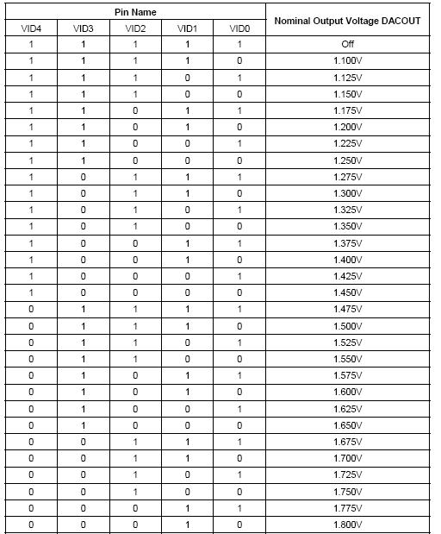
8. Common Errors:
* Touching the MOSFET leads to loss of CPU resources. Will cause severe damage to both the source level. Easy to see this MOSFET will heat very quickly after power up until a few minutes. Or maybe by 2 feet by removing from G and S mainboard.
* Death of IC fluctuations, the pulse, the driver. This error is common, and the only way change only.
* The filter capacitors were consistent source or cause dry cocoons CPU. Be careful when replacing the capacitor. It replaced the capacitor is equal to the numbers from larger and have the same output filter capacitor for the CPU.
* Remove all the main components in the short circuit still is the source. Due to the chipset North convolution. Do some motherboards, chip shared resource for North CPU vCore level.
9. Ordering check:
* Your vCore source resistance. (Often touching IC MOSFET or agitation)
* Remove each MOSFET to measure or to detect slow leaks.
* Communication from the foot of G IC MOSFET fluctuations. (Open circuit or lead to loss of contact)
* Source VCC to the IC fluctuations. (Often, this power outage due to broken fuse or touch dead IC)
Le Quang Vinh - www.lqv77.com

